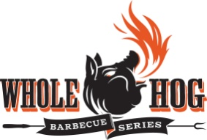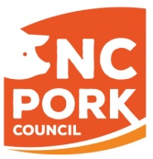

Entry Form for Horses for Healthcare BBQ Contests (May 3rd & 4th, 2019)

Team Information:

Team Name ________________________________________________________________
Chief Cook _________________________________________________________________
(All correspondence will be with the Chief Cook.)
Address ___________________________________________________________________
City _____________________________________ State _____________ Zip ____________
Telephone (Home) __________________________(Office)__________________________
Email _____________________________________

Assistant Cooks: (minimum of 1, maximum of 3)
1. ___________________________________________
2. ___________________________________________
3. ___________________________________________

Space Information:
Each team will be allocated one 15’ x 15’ outside space. Each team must provide their own shelter if desired.
If you require a larger cooking area, describe in detail your reasons, including sizes of grills, props, and any other items used in cooking set-up. Attach additional sheet, if needed.
_________________________________________________________________________________________________________________________________________________________________________________________________________________________________
Payment Information:
A $100 entry fee must be received with each entry form no later than April 5th, 2019. The contest is limited to 10 teams; entries will be accepted on a first-come, first serve basis. The Committee reserves the right to reject any entry. If entry is not accepted, your entry fee will be refunded. However, no refunds of the entry fee will be made once you have been accepted in the contest.

I have read and agree to abide by all Rules and Regulations of the Harnett Health Horses for Healthcare Barbecue Contest.

__________________________________________

Chief Cook Signature___________________________________
Return with check payable to Harnett Health Foundation no later than April 5th to:
Harnett Health Foundation PO Box 1705, Dunn NC, 28335 or email craig.lloyd@harnetthealth.org

